**Name: Nishit Rajani**

**Day – 1**

Task 1 - Learn Installing LAMP

* Install multiple versions of PHP and choose the latest version to use.

**Step 1: System Update**

sudo apt-get update

sudo apt-get upgrade

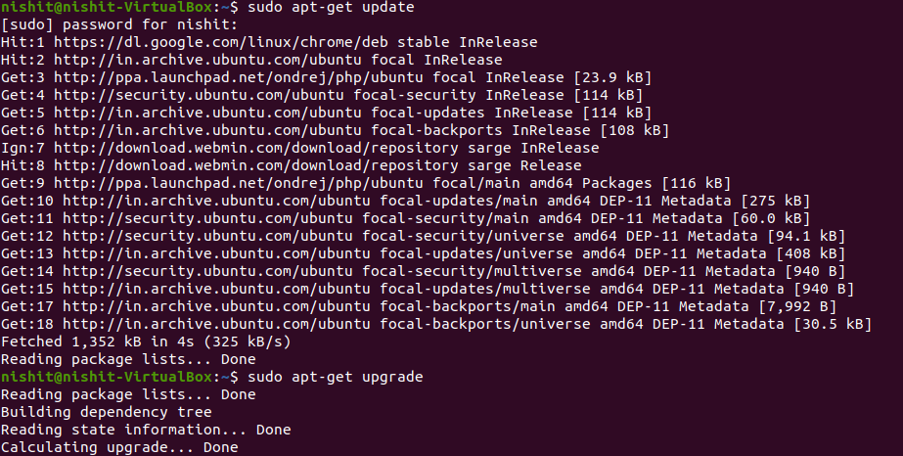

**Step 2: Execute the apt-get command to install software-properties-common:**

The software-properties-common package provides the apt-add-repository command-line utility, which you will use to add the ondrej/php PPA (Personal Package Archive) repository.

Now add the ondrej/php repository to your system. The ondrej/php PPA will have more up-to-date versions of PHP than the official Ubuntu repositories, and it will also allow you to install multiple versions of PHP in the same system:

sudo apt-get install software-properties-common -y

sudo add-apt-repository ppa:ondrej/php

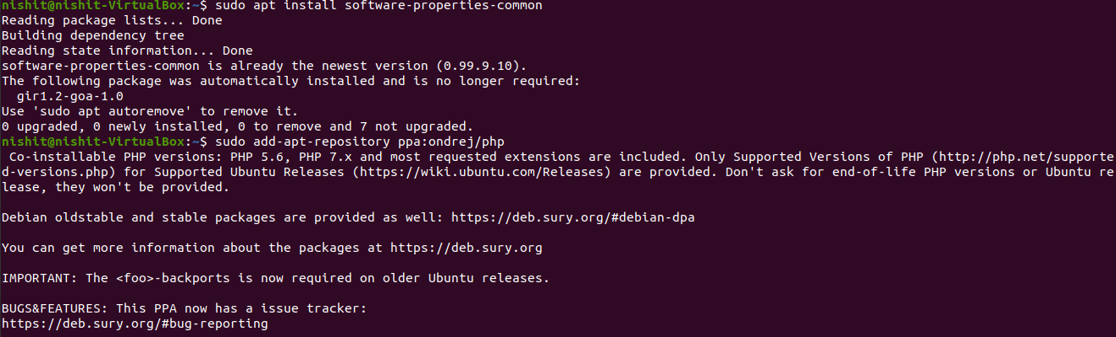

Update the repository:

sudo apt update

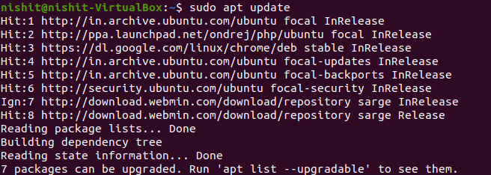

**Step 3: Next, install all the version of phpversion, phpversion-fpm, phpversion-mysql, libapache2-mod-phpversion, and libapache2-mod-fcgid with the following commands:**

sudo apt-get install php7.0 php7.0-fpm php7.0-mysql libapache2-mod-php7.0 libapache2-mod-fcgid -y

* php7.0 is a metapackage used to run PHP applications.
* php7.0-fpm provides the Fast Process Manager interpreter that runs as a daemon and receives Fast/CGI requests.
* php7.0-mysql connects PHP to the MySQL database.
* libapahce2-mod-php7.0 provides the PHP module for the Apache webserver.
* libapache2-mod-fcgid contains a mod_fcgid that starts a number of CGI program instances to handle concurrent requests.

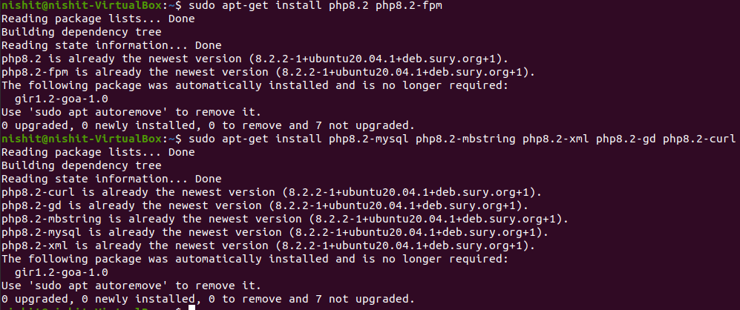

**Follow same command to install other version.**

**Step 4: Check Active PHP Version**

php -v

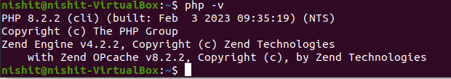

**Step 5: Switch the Default PHP Version for CLI**

sudo update-alternatives --config php

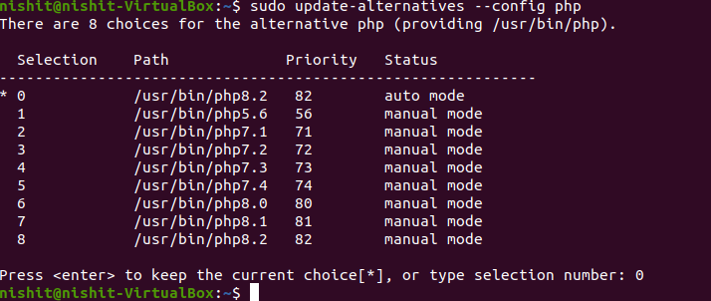

* Install PhpMyAdmin

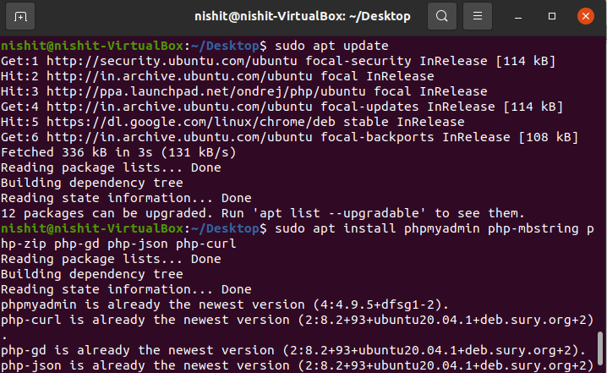

## 

## 

## 

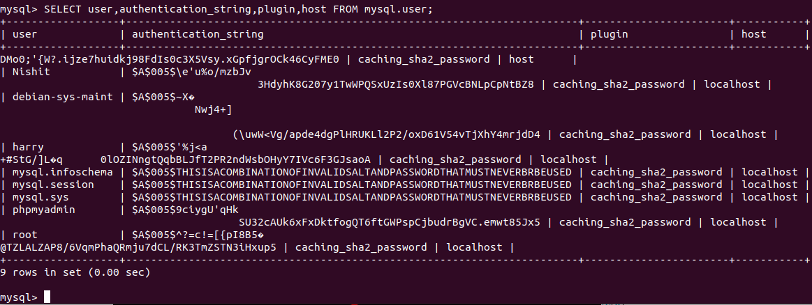

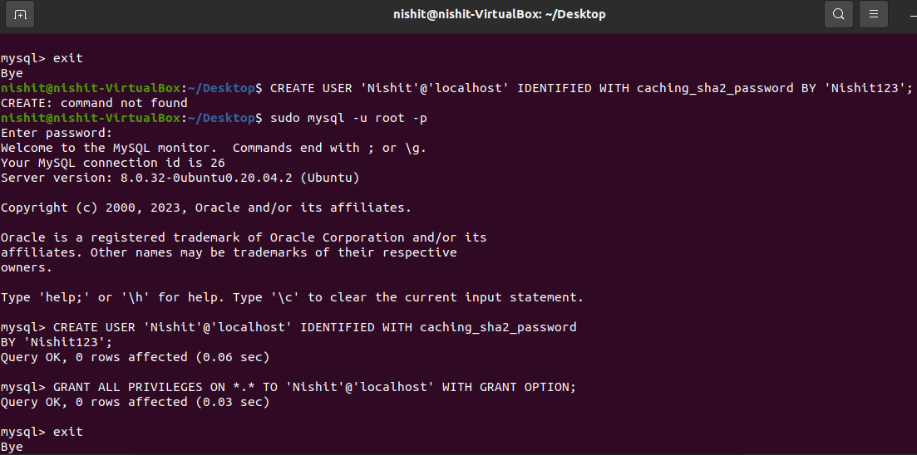

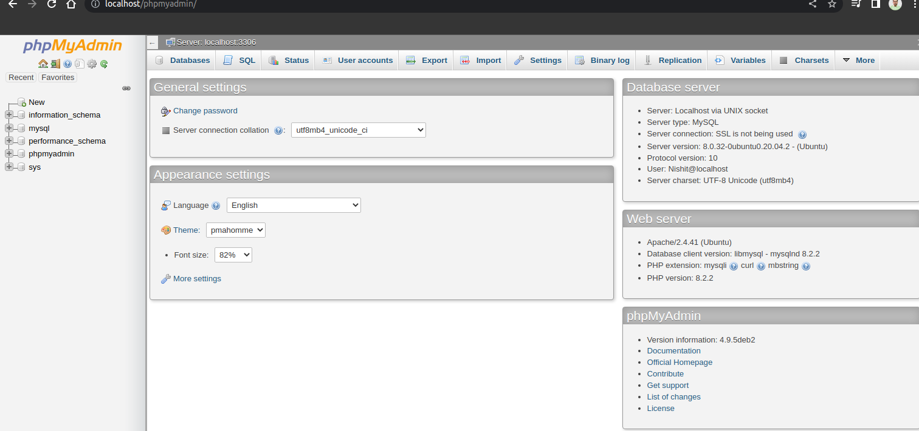

* In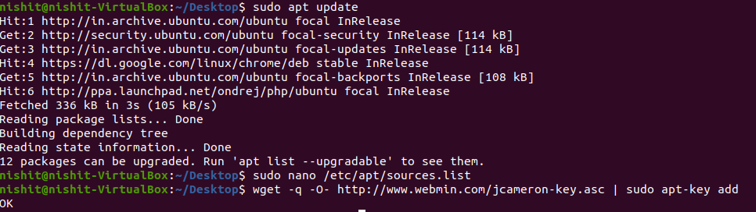stall Webmin

## 

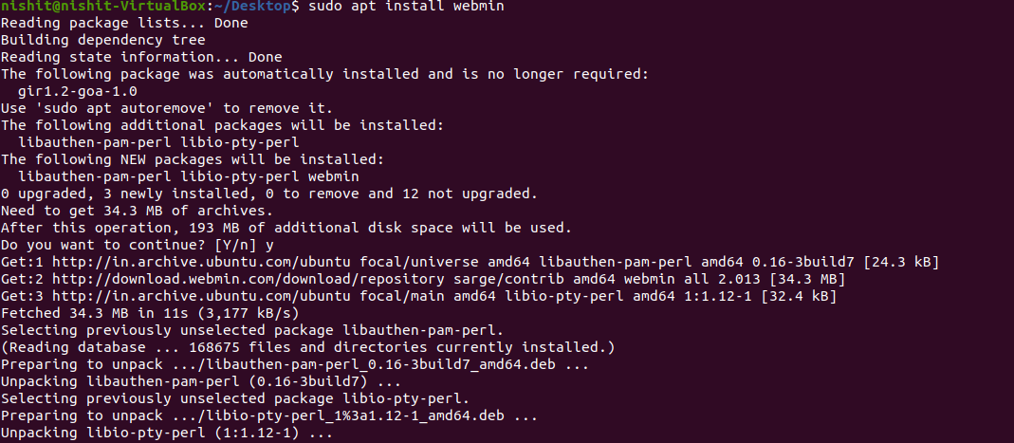

Task 2 - Learn MySQL commands

* User Create

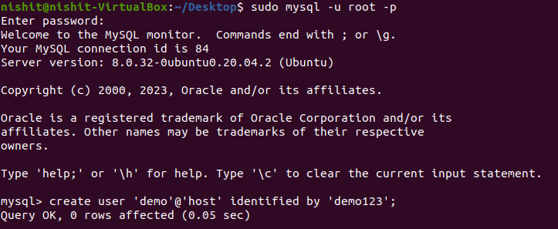

* Setting Password

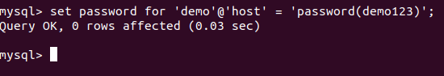

* Changing Password Plugin

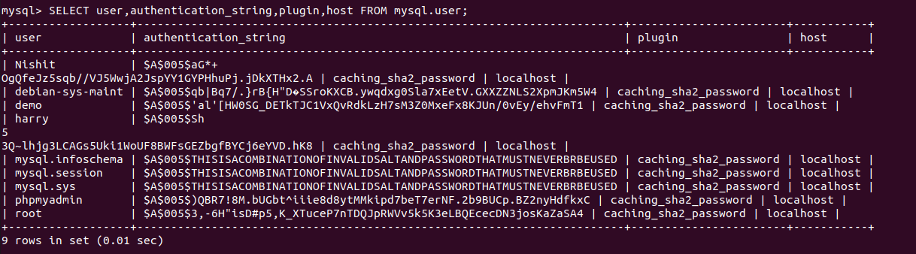

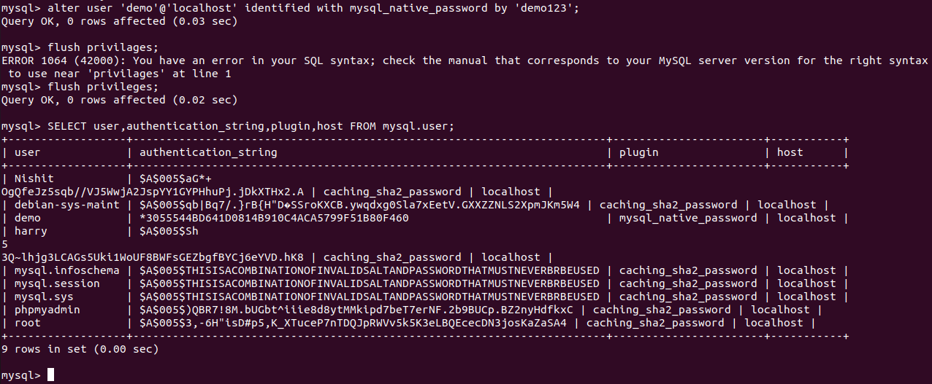

* Grant Access to a specific Database to a particular user.

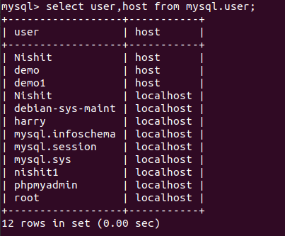

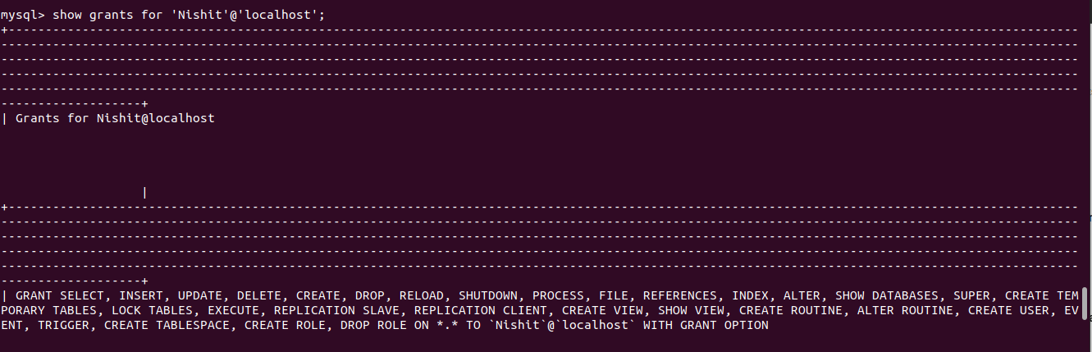

* Remote login into MySQL

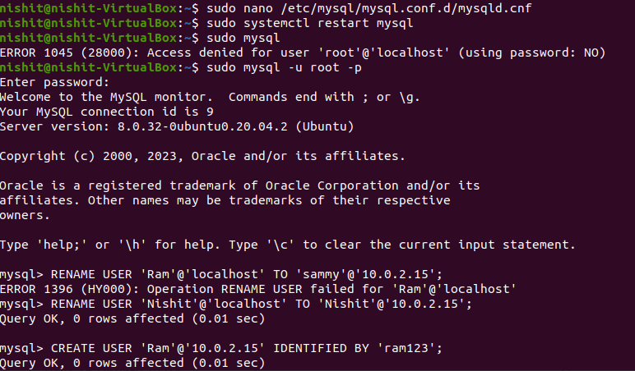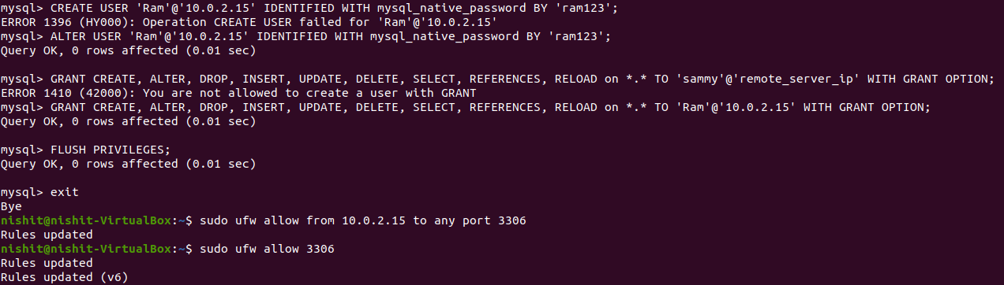

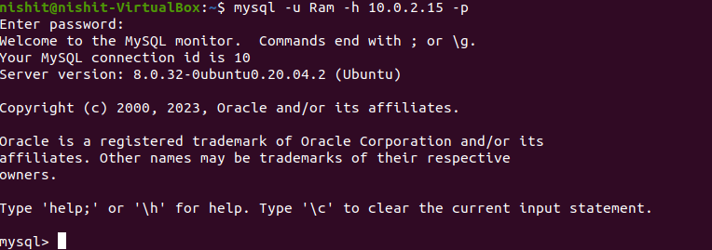

* Restricting users to specific IP addresses

Task 3 - Install ubuntu Server 20.04 OS LTS

* Install LAMP into it.

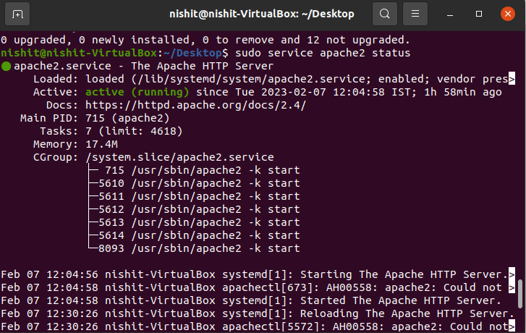

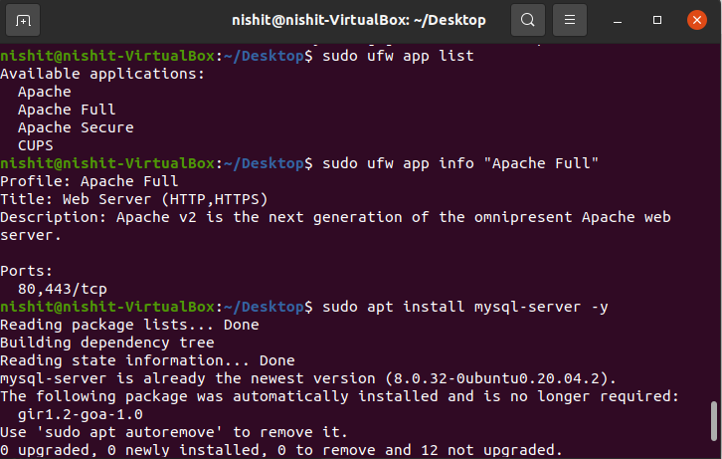

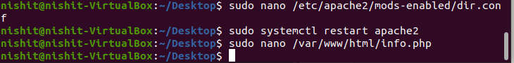

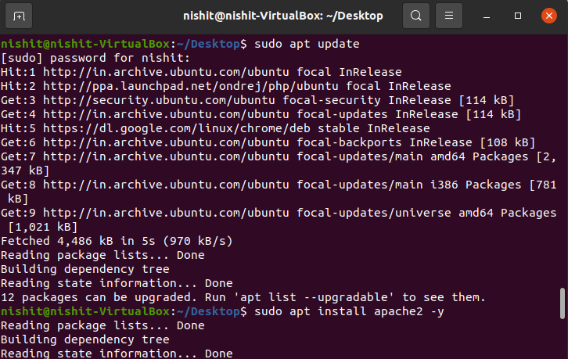

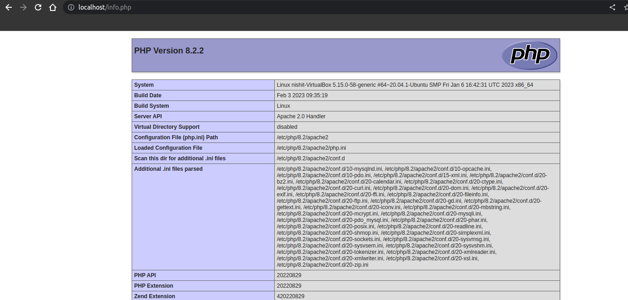

Task 4 - Learn Apache 2 Configurations

* Create a virtual host in apache2

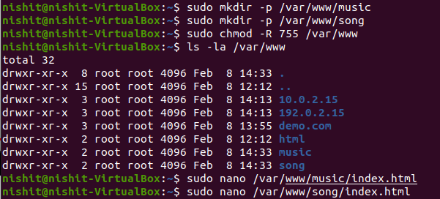

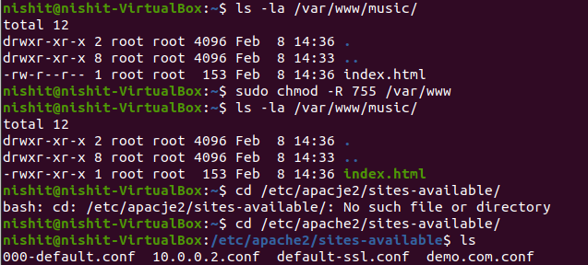

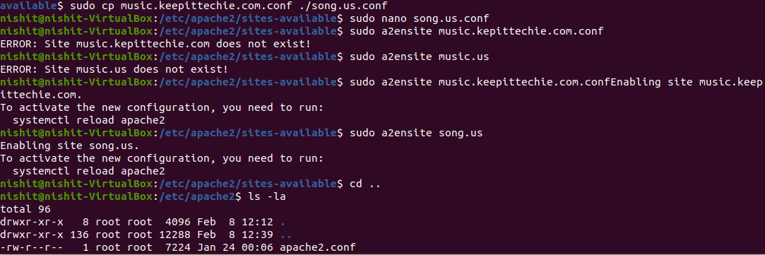

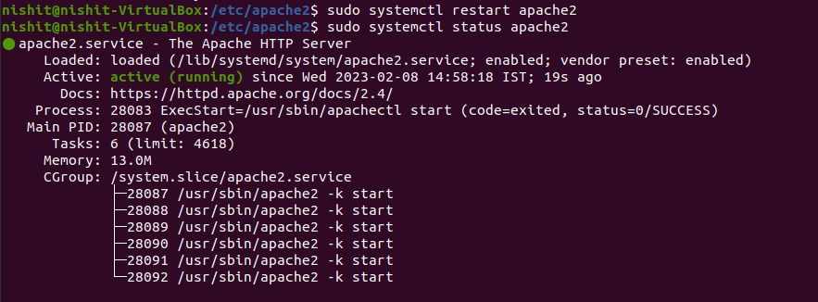

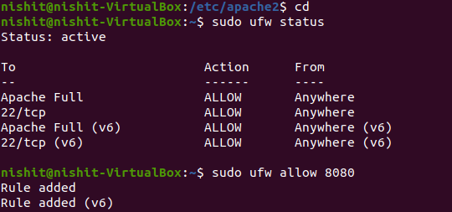

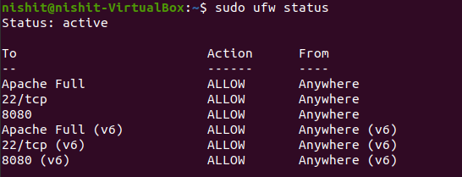

* Point a domain [www.example.com](http://www.example.com/) virtual host file and access it from your local machine

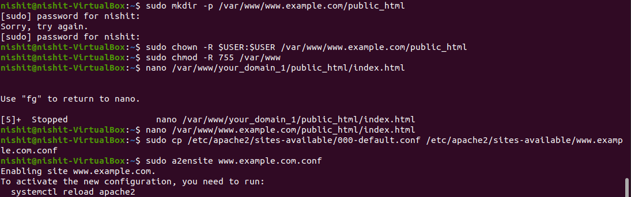

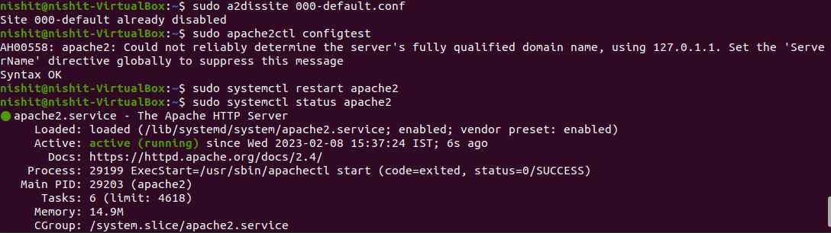

* Try open [www.example.com](http://www.example.com/) on another machine
  + List way for both Linux and Windows client machine